

**Grade: III Subject: Science**

**3.Spots and stripes come alive**

**I. Word Focus**

1.Diversity

2.Habitat

3.Solitary

4.Gregarious

5.Herbovores

6.Carnivores

7.Omnivores

8.Diet

9.Exoskeleton

10.Camouflage

11.Species

12.Sanctuary

**II. Name the following**

1.A protected area where animals can be safe and roam freely. – **Wildlife Sanctuary.**

2.A stretch of coastline or ocean where fishing and big ships are not allowed. – **Marine Sanctuary**

3.A place where animal lives. – **Habitat**

4.A path created for animals to move from one wild space to another. – **Wildlife corridor.**

**III. Answer the following**

**1.Write about exoskeleton.**

* Some animals have skeleton outside their body. Eg: Spider, Crab, Insects.
* It protects and supports them.
* It has joints that allow them to move.

**2.What type of teeth do carnivores animals?**

* Carnivores have long sharp pointed front teeth for tearing meat.
* Strong back teeth for grinding flesh.

**3.Sort the animals into the correct section of the venn diagram below**.

Lion, Deer, Monkey, Bear, Giraffe, Rat, Camel, Crocodile, Snake, Duck, Peacock, Rabbit, Crow, Rhinoceros, Swan, Elephant, Cow, Goat, Aligator

Lion,

Crocodile,

Snake, Rhinoceros, Alligator

Bear, Crow,

Rat, Humans

Deer, Cow, Elephant,

Rabbit,

Monkey

Herbivore – Plant eating animals.

Carnivore- Flesh eating animals.

Omnivore – Both Plant and flesh-eating animals.

**4.Observe the image and colour it. Write about the term Camouflage**

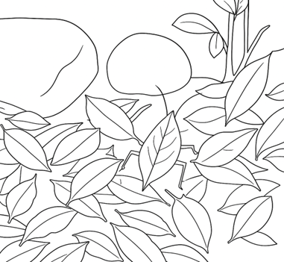

* Many animals have a pattern or design on their body coverings that help them to hide.
* This is called camouflage.
* Eg: Sticky insect.

**5.Paste the appropriate body covering of animals.**

